# How To: Remind your participant of their Participant ID

It is a good idea to remind participants of the right to withdraw their data from a study. The best place to do this is the debrief screen in PsychoPy with a tiny bit of code. If you look at the Data tab in the Experiment Info properties, you can see that a line of code specifies where the data should be saved, and in what format.

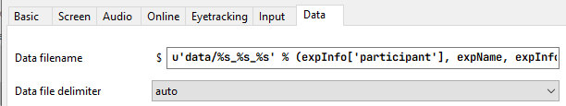

1. On the **debrief Routine**, add a **Code component** and in the **Begin Routine tab** type

msg = ‘ ‘

msg = "Your participant ID is" + expInfo['participant'] + " thank you for your time. Have an awesome day!"

1. Add a **Text component** to the **debrief** routine
2. In the text box type $msg and set to **every repeat**